ALL POST MAN APIS :

EMPLOYEE APIS : GET ALL EMPLOYEES  
  
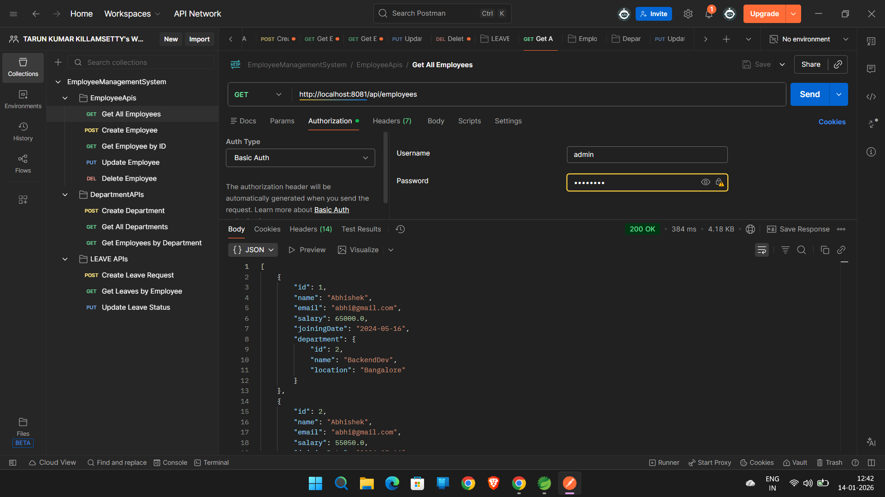

CREATE EMPLOYEE - POST

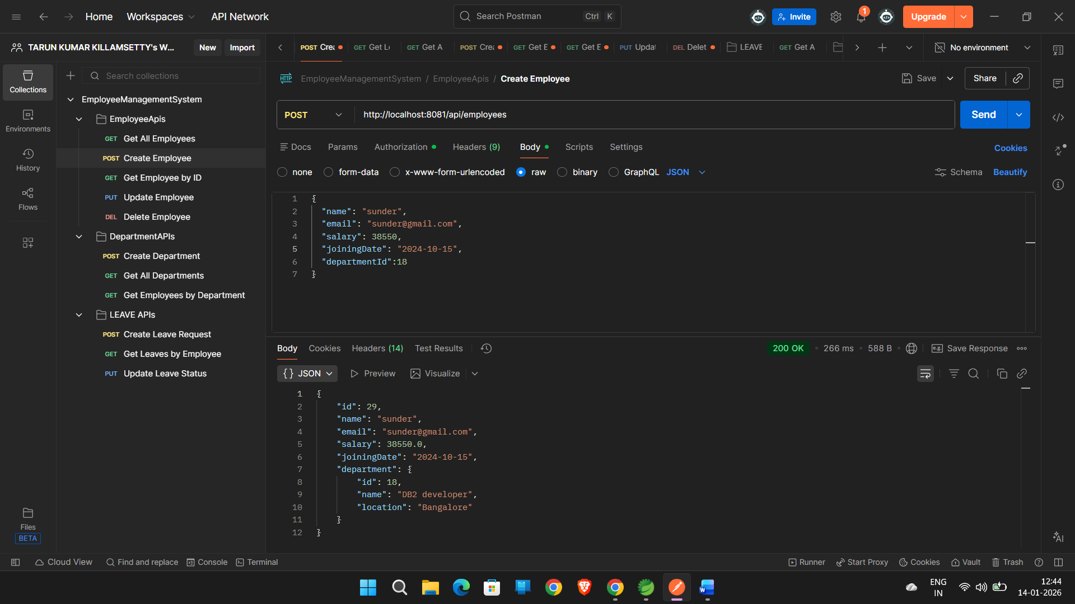

GET EMPLOYEE BY ID

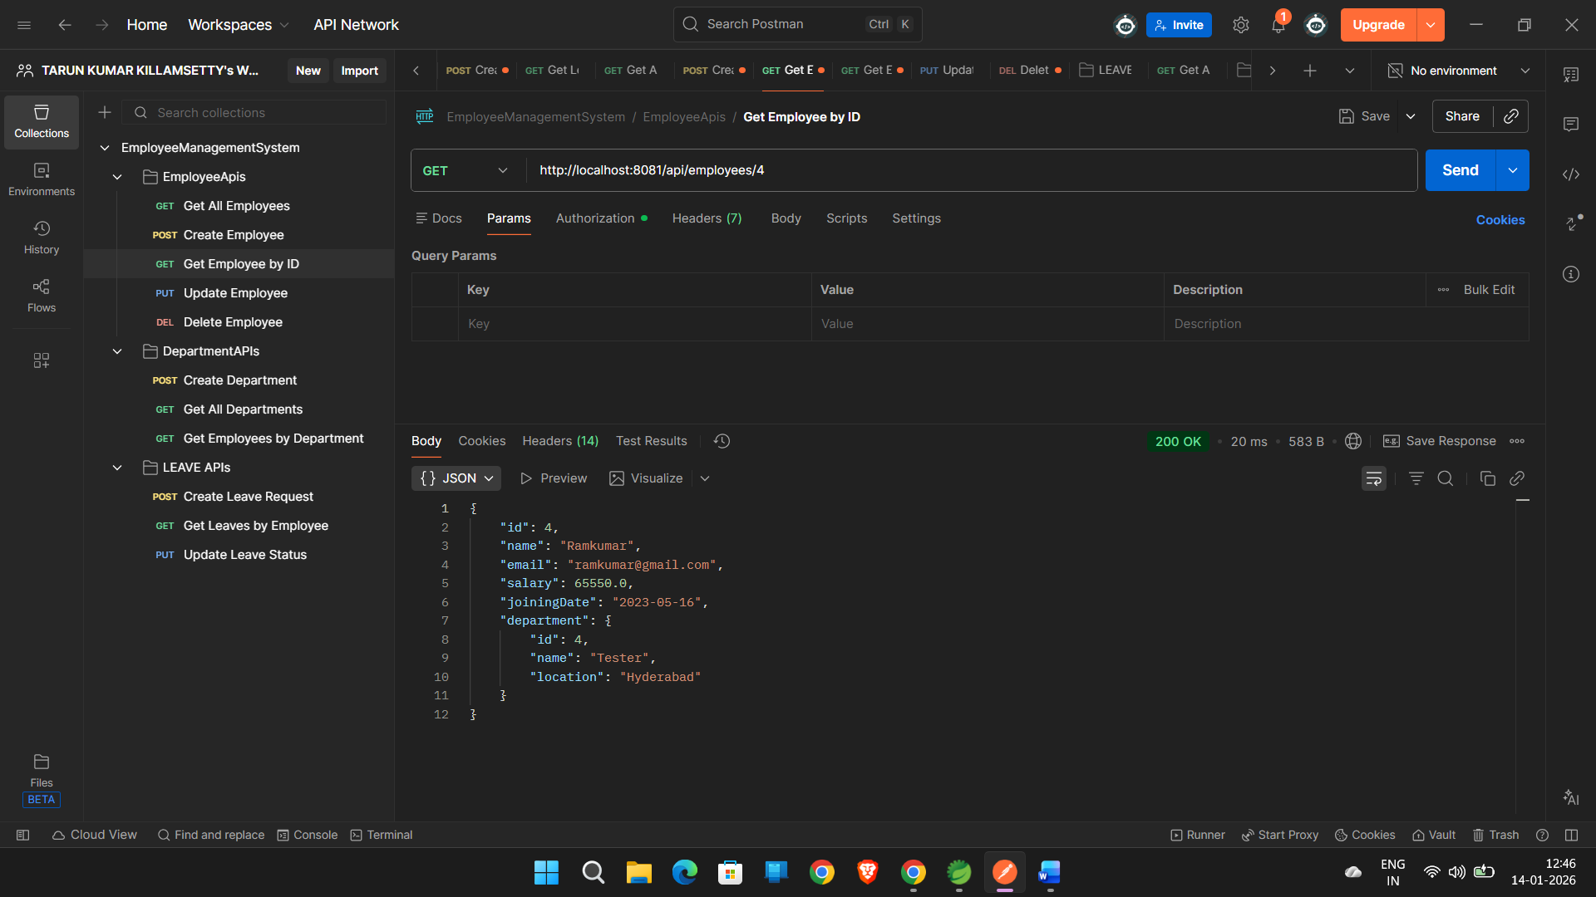

UPDATE EMPLOYEE : PUT

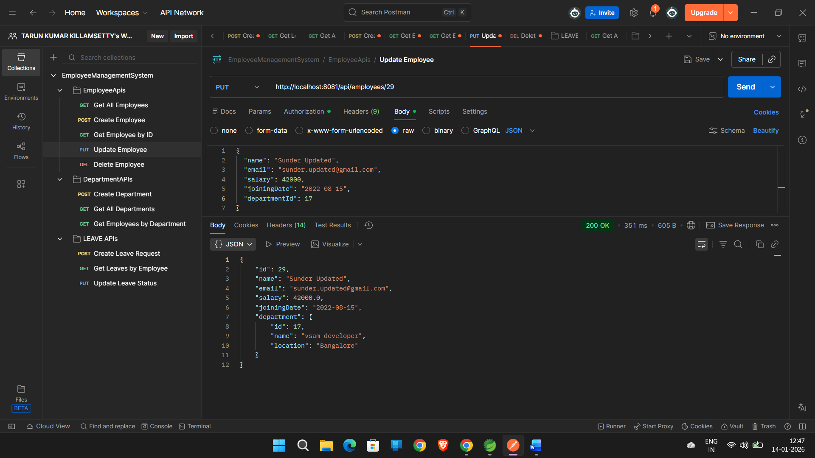

DELETE EMPLOYEE :

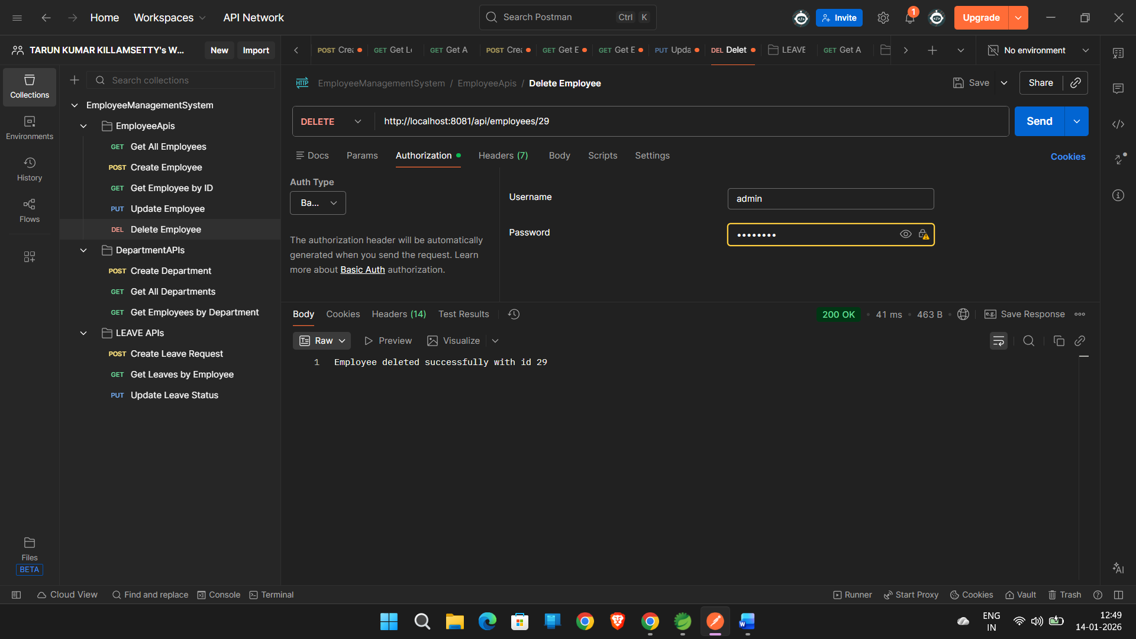

DEPARTMENT APIS :

CREATE DEPARTMENT : POST

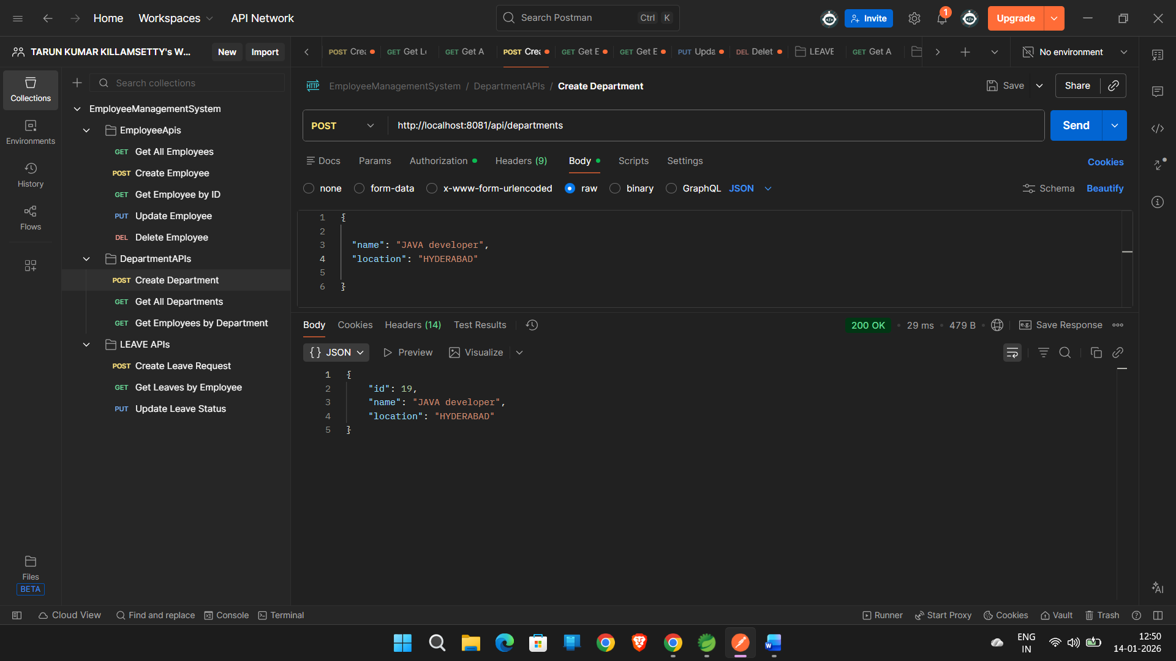

GET ALL DEPARTMENTS

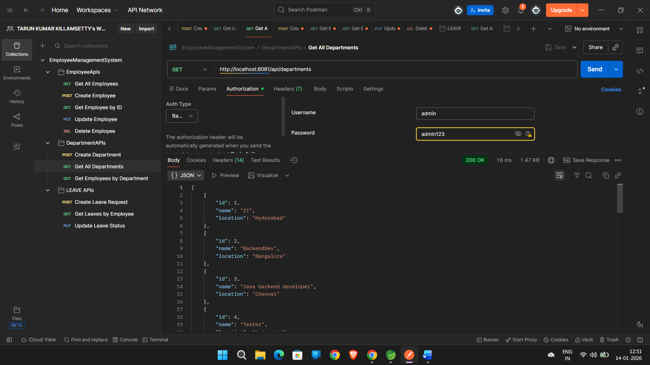

GET EMPLOYEES BY DEPARTMENT :

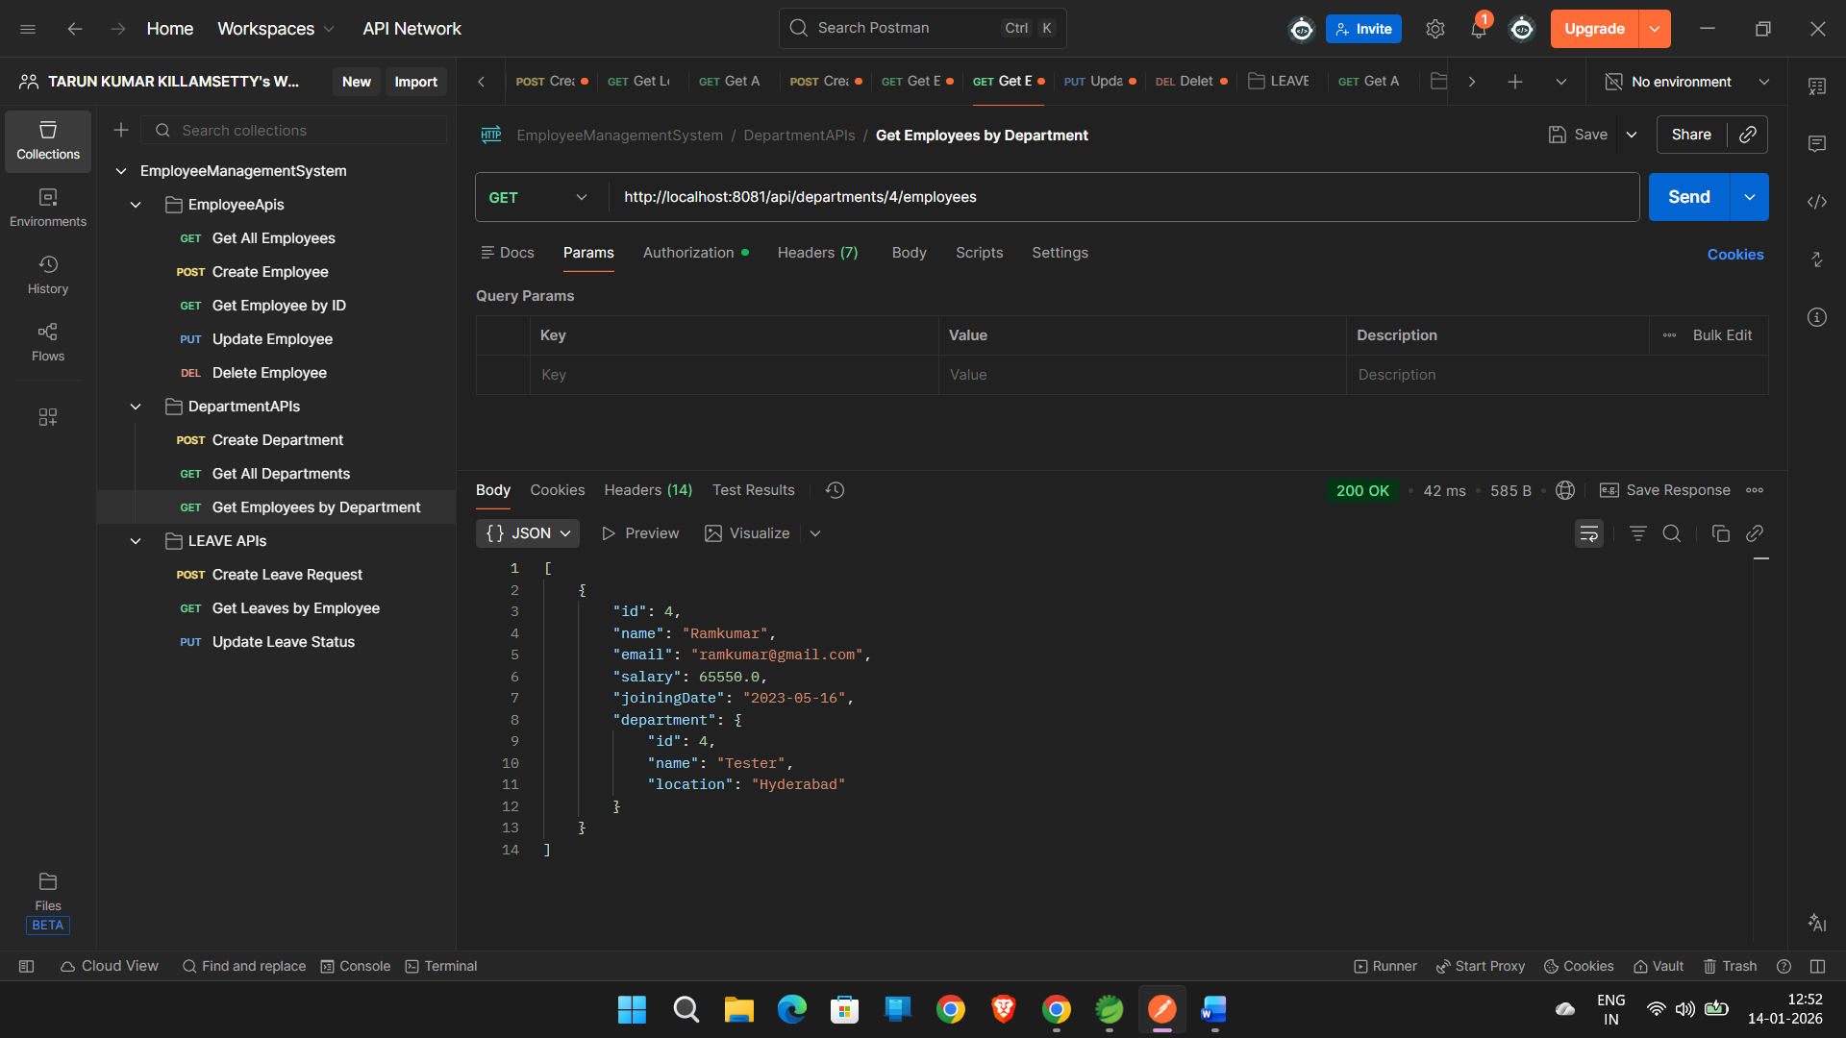

LEAVE APIS :

CREATE LEAVE REQUEST :

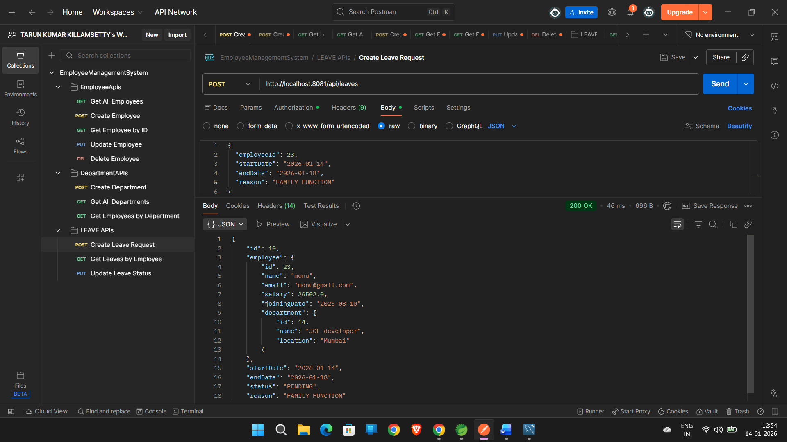

GET LEAVE BY EMPLOYEE :

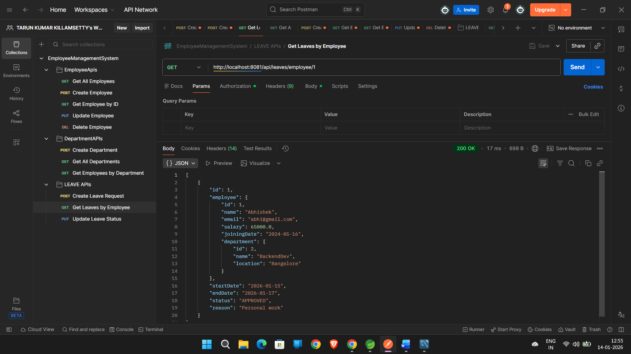

UPDATE LEAVE STATUS :

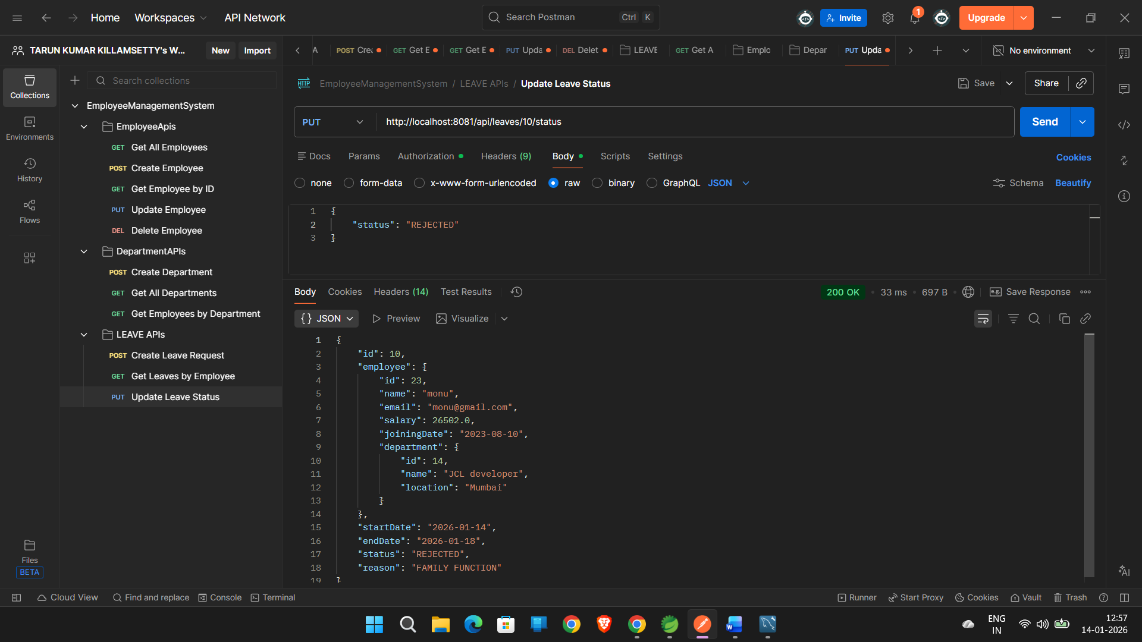

ALL APIS FROM SPRING BOOT PROJECT :

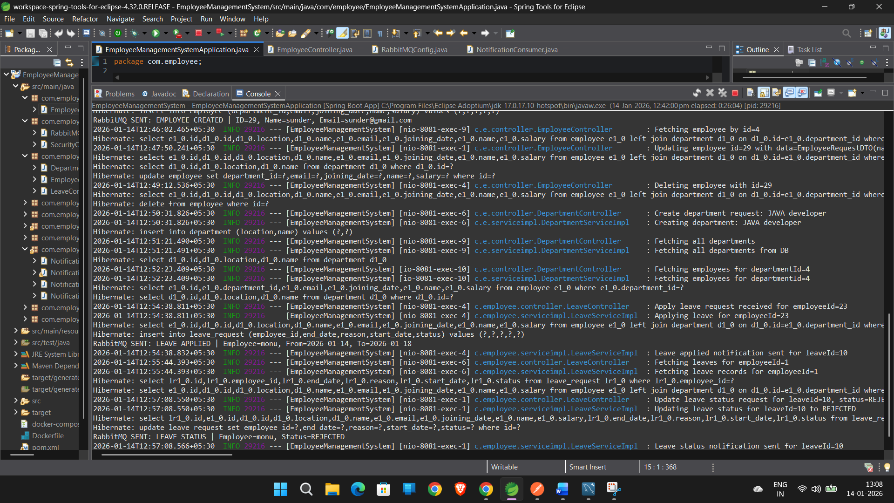

DOCKER AND RABBITMQ

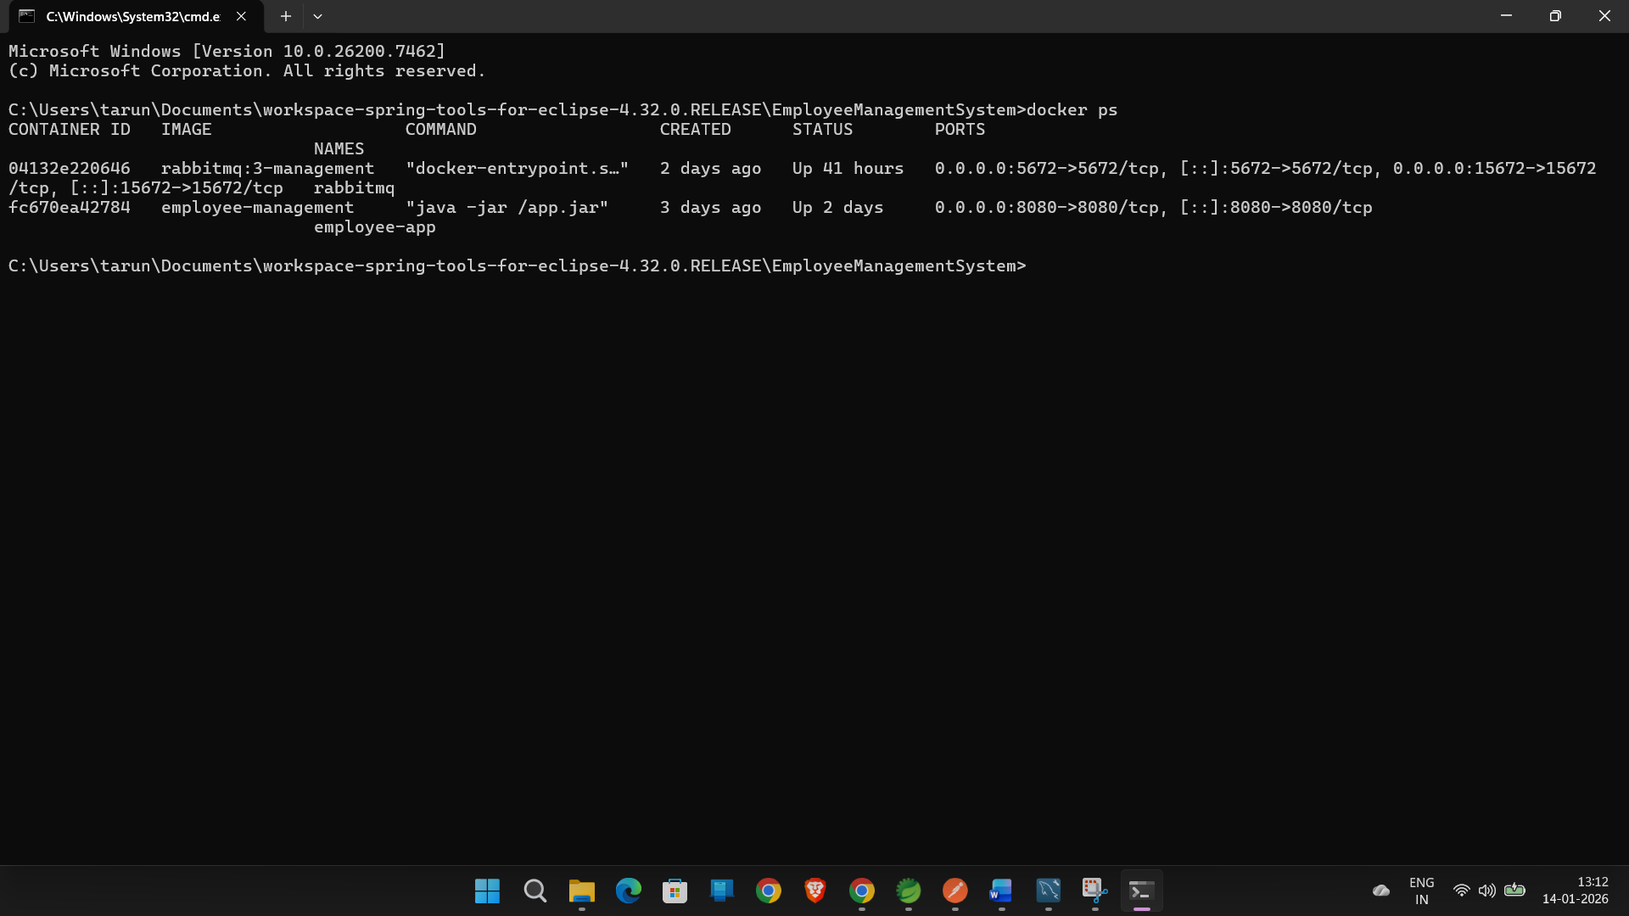

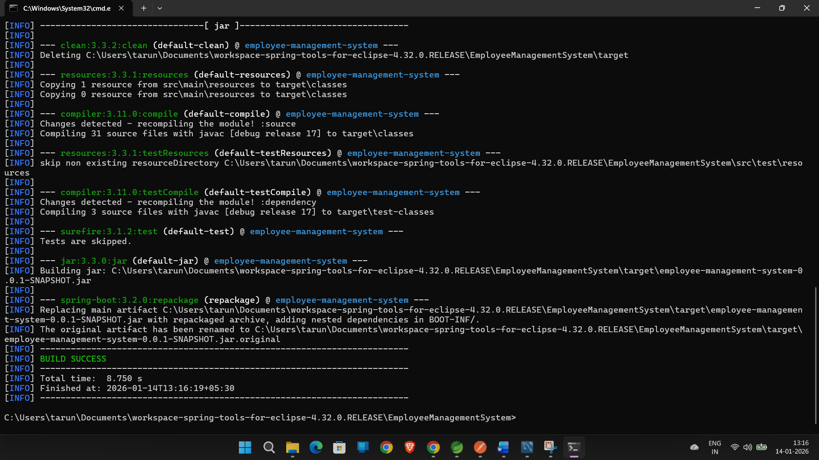

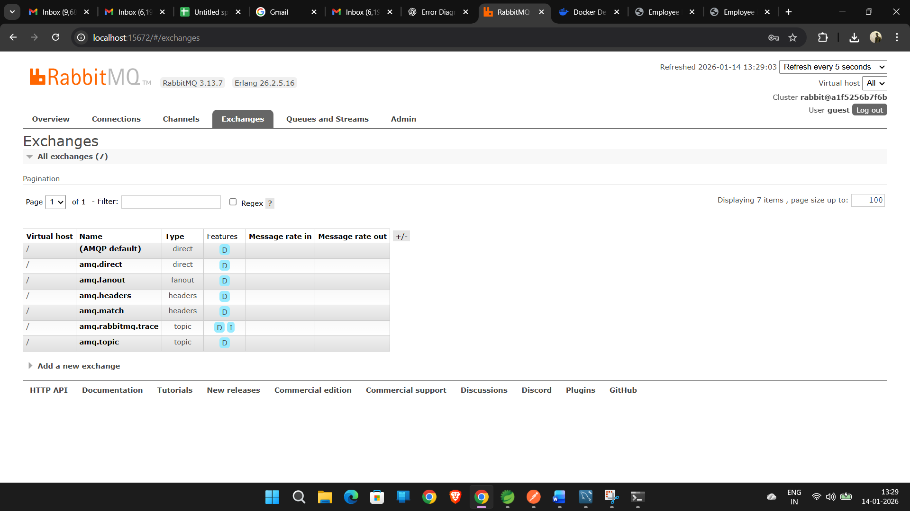

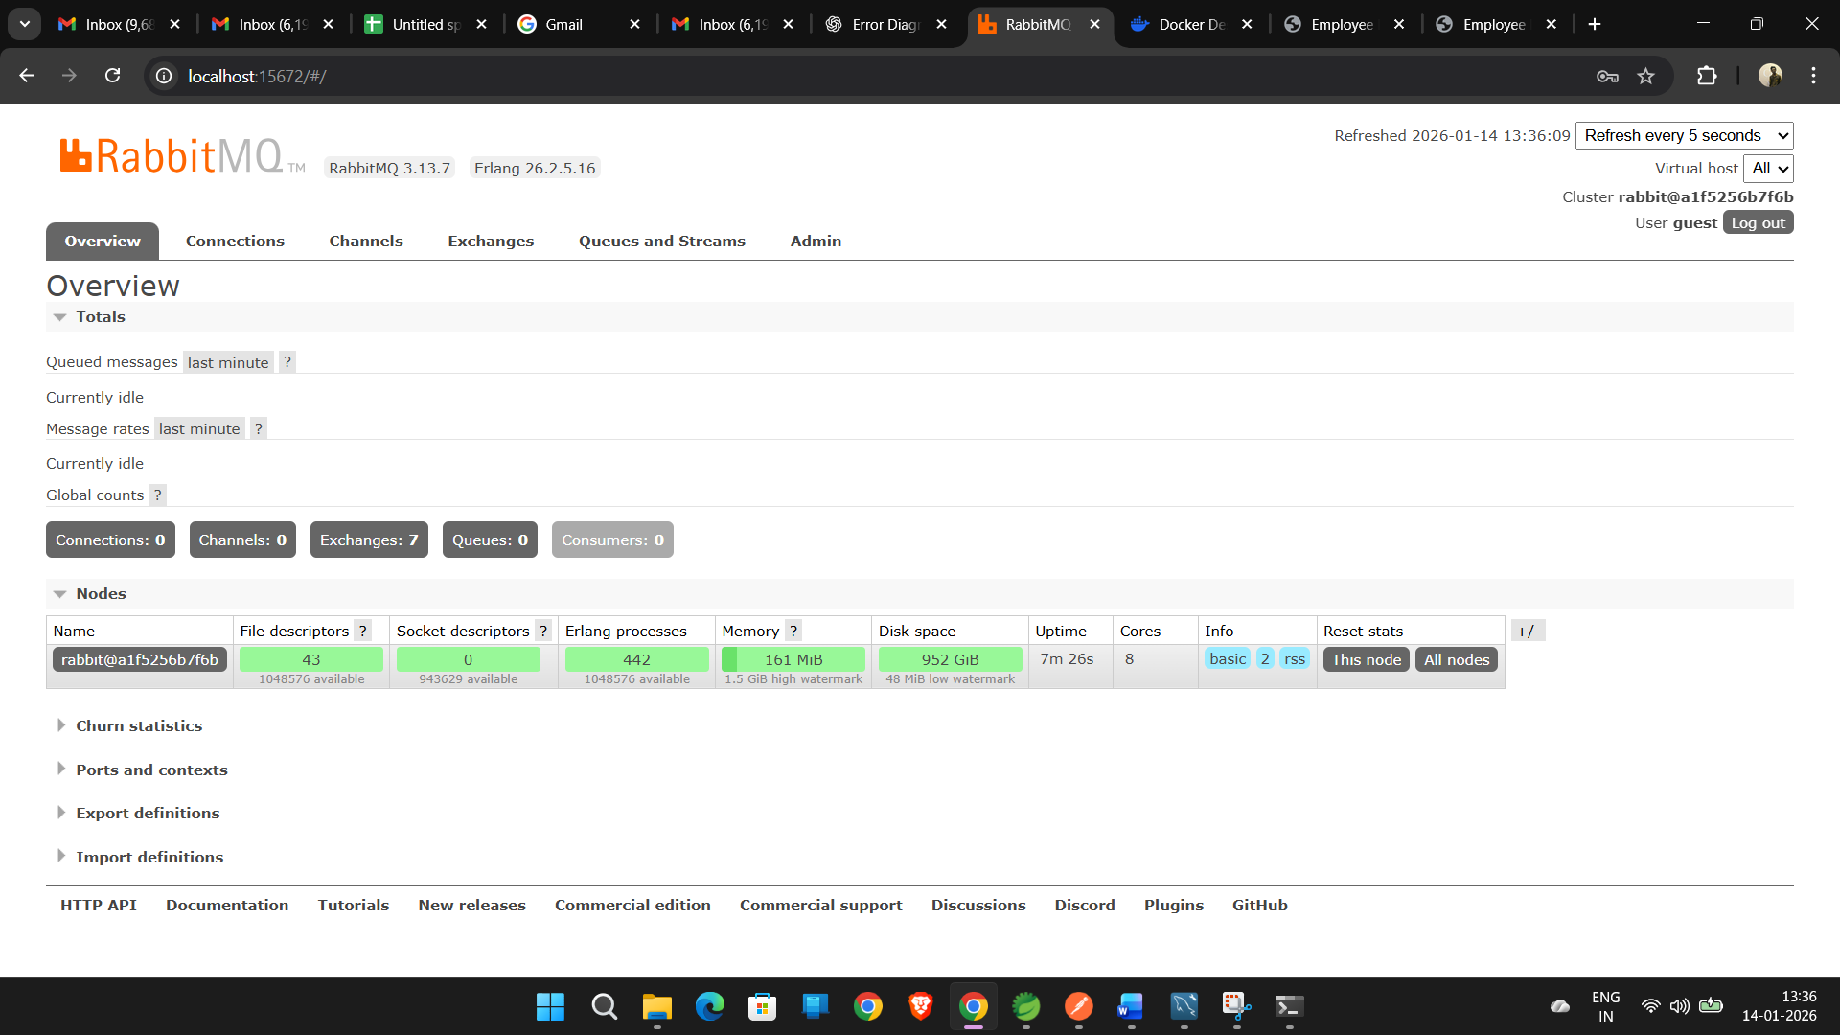

RABBITMQ NOTIFICATIONS IN STS :

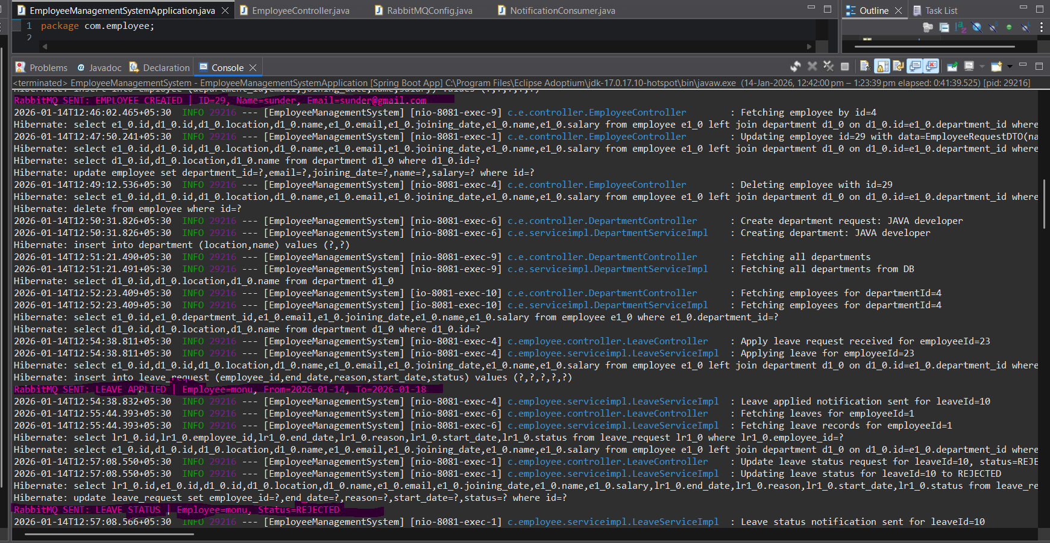

MY SQL DATABASE TABLES :

DEPARTMENT TABLE :

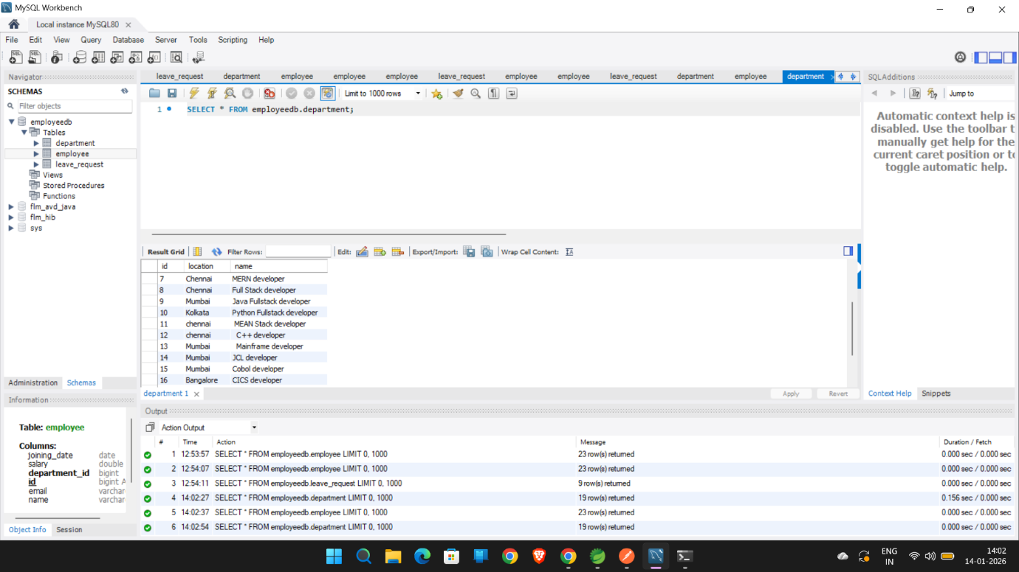

LEAVE TABLE :

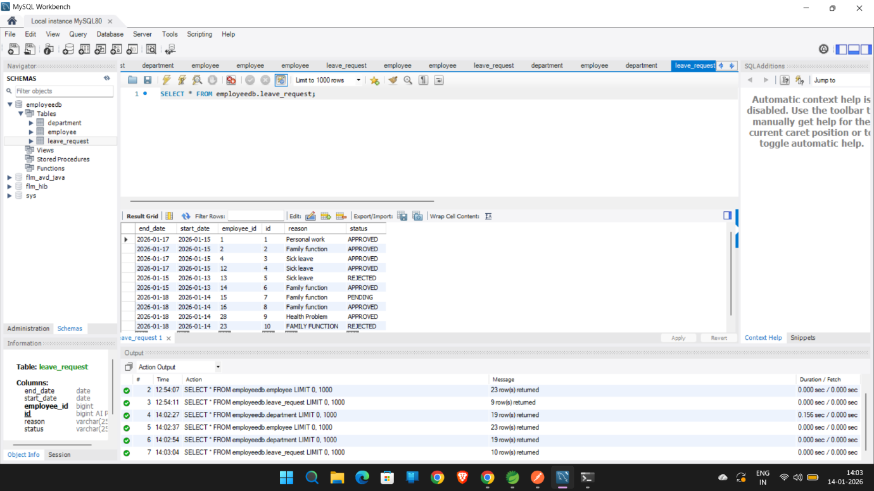

EMPLOYEE TABLE :

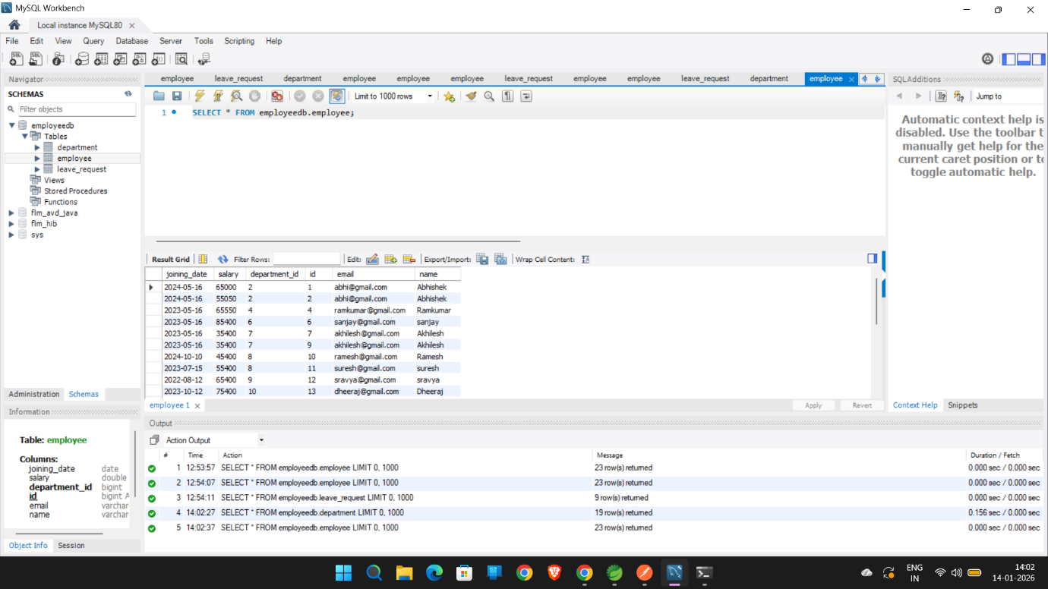

DOCKER DESKTOP :

